**Assignment No: - 2**

**Facial Recognition using OpenCV**

**Problem Statement:**

Facial Recognition Using OpenCV and Deep Learning for Binary Classification.

**Objective:**

* Understand the fundamentals of face detection and recognition.
* Learn to preprocess face data and extract facial embeddings.
* Implement a deep learning-based model to classify faces.
* Evaluate the model's accuracy and performance.
* Visualize the training process and performance metrics.

**S/W Packages and H/W apparatus used:** Operating System: Windows/Linux/MacOS, Kernel: Python 3.x, Tools: Jupyter Notebook, Anaconda, or Google Colab, Hardware: CPU with minimum 4GB RAM; optional GPU for faster training

**Libraries and packages used:** OpenCV, TensorFlow/Keras, Dlib, face_recognition, NumPy, Pandas, Matplotlib, Scikit-Learn

**Theory:**

**Definition:** A facial recognition system is a technology capable of identifying or verifying a person from a digital image or video frame. The system works by detecting facial features and matching them against a pre-stored database. In binary classification, the task is to distinguish between two classes, typically "face" and "no face."

**Structure:** It consists of:

* **Face Detection Module:** Detects the presence of a face in the input image using techniques like Haar Cascades or deep learning models (SSD or YOLO).
* **Feature Extraction Module:** Extracts unique facial features from the detected region using Convolutional Neural Networks (CNNs).
* **Classification Module:** Binary classifier (CNN or SVM) that outputs whether the detected region contains a face or not.

**Activation Functions:** Functions like ReLU (Rectified Linear Unit), Sigmoid, and SoftMax are used to introduce non-linearity into the classification model, enabling it to learn complex patterns.

**Backpropagation:** A critical algorithm for training the CNN-based model, where the error between predicted and true labels is propagated backward to update the weights in each layer to minimize classification error.

**Methodology:**

1. **Data Collection:** Gather a dataset containing face and non-face images.
2. **Preprocessing:** Use OpenCV for face detection and resize images to a uniform size. Normalize pixel values.
3. **Model Architecture:** Build a CNN using Keras/TensorFlow to classify images as face or no face.
4. **Training:** Train the model with labeled images, using binary cross-entropy loss and accuracy as a metric.
5. **Evaluation:** Test the model's performance using unseen data, evaluating accuracy and other metrics.
6. **Prediction:** Use the trained model to classify new images as containing a face or not.

**Advantages:**

* **High Accuracy:** Deep learning provides high precision in recognizing and classifying faces.
* **Real-Time Processing:** OpenCV allows for real-time face detection and recognition.
* **Automation:** The system can automate tasks such as authentication and access control.

**Limitations:**

* **Data Quality and Quantity:** Facial recognition systems require a large, diverse, and high-quality dataset for training. Poor-quality images or insufficient training data can lead to inaccurate predictions and difficulty in generalizing to new faces.
* **Illumination and Pose Variability:** Variations in lighting, pose, facial expressions, and occlusions (like glasses or hats) can significantly affect the model's accuracy, leading to false positives or false negatives.
* **Privacy Concerns:** Facial recognition technology raises significant ethical and privacy issues. The unauthorized collection and use of facial data can infringe on personal privacy rights, leading to regulatory and legal challenges.
* **Computational Complexity:** Deep learning-based facial recognition models, especially with large-scale datasets, require significant computational resources for training and deployment, which may not be suitable for real-time or low-power devices.
* **Overfitting:** If the model is overly complex or trained on limited or biased data, it can overfit to the training data, resulting in poor performance on real-world or unseen images.
* **Adversarial Vulnerabilities:** Facial recognition systems can be susceptible to adversarial attacks, where small perturbations in the image can fool the system into misclassifying a face.

**Applications:**

* **Security and Surveillance:** Facial recognition is widely used in security systems for access control, identifying individuals in surveillance footage, and monitoring high-security areas.
* **Biometric Authentication:** Facial recognition is employed in smartphones, laptops, and other devices for user authentication, providing a convenient and secure alternative to passwords.
* **Law Enforcement:** Police and other law enforcement agencies use facial recognition to identify suspects in criminal investigations, locate missing persons, or track criminals across large datasets.
* **Healthcare:** Facial recognition can be used in healthcare to monitor patient conditions, detect emotional states, and assist in diagnosing genetic disorders based on facial features.
* **Retail and Marketing:** In retail environments, facial recognition is used for personalized marketing, customer identification, and enhancing customer experience by analyzing shopping patterns.
* **Time and Attendance Systems:** Many businesses employ facial recognition for tracking employee attendance and enhancing workplace security by automating time-in/time-out processes.
* **Smart Cities:** Facial recognition technology can be integrated into smart city infrastructure for traffic monitoring, crowd control, and improving public safety.

**Working / Algorithm:**

**Step 1:** Load Dataset

The CIFAR-10 dataset, which contains 60,000 32x32 color images across 10 different classes, is loaded using the TensorFlow/Keras datasets API. The dataset is split into training and test sets, with 50,000 images for training and 10,000 images for testing.

**Step 2:** Preprocess Data

The images are normalized by dividing each pixel value by 255. This scales the pixel values between 0 and 1, improving the efficiency of model training.

**Step 3:** Visualize Data

A sample of 25 images from the training set is displayed using matplotlib. Each image is labeled with its corresponding class name (e.g., airplane, automobile, etc.).

**Step 4:** Define CNN Model Architecture

A Convolutional Neural Network (CNN) is created using the Sequential API in Keras:

First Convolutional Layer: 32 filters with a 3x3 kernel, ReLU activation, followed by max-pooling (2x2).

Second Convolutional Layer: 64 filters with a 3x3 kernel, ReLU activation, followed by max-pooling (2x2).

Third Convolutional Layer: 64 filters with a 3x3 kernel and ReLU activation.

Flatten Layer: Converts the 3D feature maps into 1D vectors.

Dense Layer: Fully connected layer with 64 units and ReLU activation.

Output Layer: Dense layer with 10 units (for 10 classes) and SoftMax activation for multiclass classification.

**Step 5:** Compile the Model

The model is compiled with the Adam optimizer, sparse categorical cross entropy loss (appropriate for multiclass classification), and accuracy as the performance metric.

**Step 6:** Train the Model

The model is trained for 10 epochs on the training data. During each epoch:

The model processes the training data in batches (with a batch size of 128).

The loss and accuracy are computed for both the training and validation (test) sets.

Validation data (test set) is used to monitor the model’s performance after each epoch.

**Step 7:** Evaluate the Model

After training, the model is evaluated on the test data to compute the final test loss and accuracy.

**Step 8:** Visualize Training History

A plot is generated showing the model’s accuracy and validation accuracy over the training epochs.

**Step 9:** Print Test Accuracy

The final test accuracy is printed, indicating how well the model performs on unseen test data.

**Diagram:**

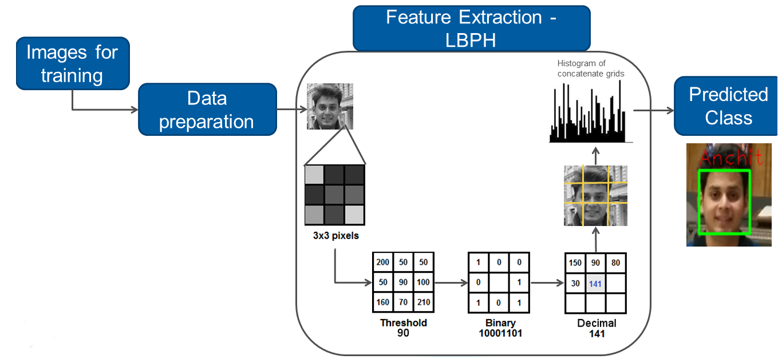

**Conclusion:**

The Feedforward Neural Network (FNN) is an effective and flexible tool for facial recognition tasks, capable of learning complex patterns in image data. Its ability to handle non-linear relationships makes it suitable for distinguishing between different facial features. While FNNs offer strong predictive capabilities, challenges such as the need for substantial computational resources, risks of overfitting, and the necessity for meticulous hyperparameter tuning must be addressed. When effectively managed, FNNs can deliver robust performance in facial recognition applications, enhancing various technological solutions in security, user authentication, and more.